This sample emergency action plan has been prepared by the Utah Division of Housing and Community Development to provide assistance in developing a comprehensive emergency plan. It should not be used without consideration of the unique conditions and requirements at each project site. It will be necessary to modify this sample plan for your specific needs.

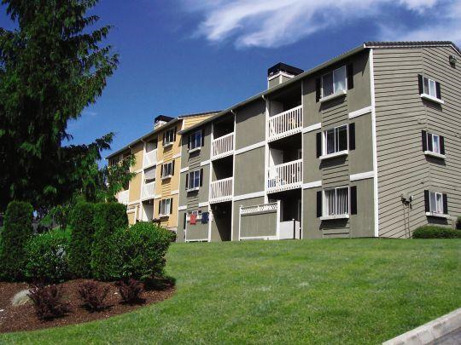

Hidden Valley Apartments
Glennville Management
153 Main Street
Smartsville, UT 84123
(801) 555-5555

Objective
The following is a plan to prepare for most anticipated emergencies. By auditing the building and location vulnerabilities, establishing communication channels, formulating supply sources, and constituting effective protocols and procedures, human lives will be preserved and restoration following a disaster will be expedited.

The intent of the plan is to ensure residents and staff are safe and living in a healthful environment. Those staff and residents assigned specific emergency duties under the plan should be provided the necessary and regularly scheduled training and protective equipment to ensure their safety and effectiveness.

Revised 7/30/2026

Communication

Emergency Plan Coordinator
Name | Office | Office Phone | Cell Phone
Michael Wilson (Property Manager)* | 153 | 801-234-5678 | 801-589-5555
Jane Smith (alternate) | 187 | 801-556-5412 | 801-673-5555
*The Coordinator is responsible for updating the plan and may be contacted for more information.

Agency Contact Information
Contact | Name | Office Phone | Cell Phone
Property Manager | Michael Wilson | 801-234-5678 | 801-598-1351
Regional Director | Patricia Thomas | 801-456-1231 | 801-321-9876
Executive Director | Barbara Jones | 801-456-1233 | 435-548-4563
Human Resources | Jennifer Davis | 801-456-1239 | 435-423-7987
Case Manager | George Harris | 801-478-5611 | 801-987-6543

Emergency Contact Information *For Emergencies Dial 911
Organization | Contact | Phone
Fire Department | Smartsville, FD | 435-884-3343
Police Department | Smartsville, PD | 435-884-6881
Smartsville City Emergency Contact | Donald Martinez | 435-543-4283
Salt Lake County Emergency Contact | Jackie Nicholl | 801-468-2156
Gas Company | Questar Gas | 1-800-323-5517
Power Company | Rocky Mountain Power | 1-877-548-3768
Telephone Company | Qwest | 1-877-348-9007
Insurance Agency | All Farmers State | 1-800-531-2314
County Health Department | --- | 801- 451-3340

Stairwell Emergency Monitor
Each stairwell has a volunteer assigned as an Emergency Monitor (EM). The role of the EM is to account for and assist residents in their stairwell throughout the evacuation process. The EM should be aware of any special requirements of the residents in their stairwell so they will know how to help in an emergency. During the emergency the EM is report on the condition of each tenant in their assigned area to the Emergency Coordinator (EC). Tenants are to report any emergency directly to the EM (after alerting emergency officials) who will then relay the message to the Emergency Coordinator. If the EM is unavailable, the tenant is to contact the EC directly, who will notify the other EM’s. Each EM is to receive basic emergency management and first-aid training annually. The following is a list of current EM’s:
Name | Apt | Home Phone
James Smith | 121 | 801-544-4444
Robert Gumbo | 143 | 801-123-4567
Mary Williams | 165 | 801-765-4321
Charles Martin | 183 | 801-423-8989
Daniel Jackson | 169 | 801-789-1234
Linda Garcia | 131 | 801-556-5412

Vulnerability and Building Assessment
Description: Built in 1985 and later renovated in1998, the structure is a standard wood frame-on-concrete foundation building. This property caters to elderly residents, and there are a few tenants who are disabled. Part of the renovation included installing steel reinforcements to the concrete foundation. Sidewalks and parking lots were either resurfaced or completely replaced. Cosmetic repairs include new siding on exterior surfaces, architectural asphalt roof shingles, and new trees along the east property line. There is one buildng with six stairwells (6 units per stairwell). The property manager’s office is located in the middle of the building in unit 153. There is a small maintenance shed near the southeast side of the main building. The main structure on the property is a 3 story building and includes 36 units.

Each unit has a 50 gallon water heater, a forced-air furnace, and a window air conditioning unit; all large appliances are serviced and replaced when necessary. During the renovation, emergency lighting was installed in walkways and stairs. Emergency alarms were replaced. Exterior (or common area) fire extinguishers were installed on each floor, and water heaters were secured. Fire alarms and lighting are tested on an annual basis. Alternate emergency notification devices for residents with special needs are in-place, including bright LED and strobe lights for persons who are deaf or hard of hearing, and sirens and alarms for the seeing disabled. Emergency Monitors (Ems) also act as assisants and guides during evacuations. These systems are tested annually by the property manager. (Copy of vulnerability and building assessment checklist attached as apendix)

Structural Assessment
Assessments of structural vulnerabilities are to be performed by a licensed structural engineer every ten years. The most recent structural assessment was performed by Smoot and Associates Engineering on June 25, 2007. A detailed breakdown of their findings and recommendations is found in the appendix. Please refer to the chart and indicate if and when the findings were repaired.

Vulnerability Assessment
The following analysis chart is used as an exercise to reveal which hazard is most likely to occur at this property location. This chart, combined with the Natural Disaster Mitigation Plan published by the Wasatch Front Regional Council (WFRC), shows that at our location, we face a higher likelihood of earthquakes, winter storms, power outages, and fires. For a thorough discussion of the levels of risk for these disasters, please see the mitigation plan used by the WFRC. In all cases, a certain amount of preparedness on the part of the residents ought to be exercised and promoted.

VULNERABILITY ANALYSIS CHART
Type of Hazard | Probability |  | Human Impact | Property Impact | Internal Resources | External Resources | Total
 | High  5 | Low  1 | High  5 | Low  1 | Weak  5 | Strong  1
Earthquake | 4 |  | 5 | 3 | 5 | 3 | 20
Fire | 4 |  | 3 | 4 | 4 | 1 | 16
Winter Storm | 4 |  | 3 | 4 | 4 | 3 | 18
Power outage | 3 |  | 3 | 4 | 3 | 2 | 15
Flood | 1 |  | 3 | 4 | 3 | 2 | 13
Man-made disasters | 3 |  | 3 | 3 | 3 | 2 | 14

Earthquake - Nearly 80% of the state population lives along the Wasatch Front. The Wasatch Front lies atop the Wasatch Fault which extends from Malad, ID to Fayette, UT. Large earthquakes (over 5.0 in magnitude) have not been common in recent years, however scientists and seismologists predict the area is overdue for an event over 5.0 in magnitude. Earthquakes can occur without warning and can disrupt gas, electric, transportation, and telephone services; they may trigger landslides, avalanches, flash floods, and fires near Hidden Valley Apartments. Much of the damage and injuries stem from the aftermath of earthquakes: falling debris, liquefaction of soils, fires, building instabilities, etc.

Building Vulnerabilities - Historically, wood framed structures have a certain amount of ‘give’ during an earthquake. Unfortunately, concrete foundations are far more rigid, and are thus vulnerable to earth shaking. To minimize some of the damaging effects of a typical earthquake, we have strengthened the columns and building foundation and reinforced exterior lighting fixtures and railings.

An analysis of earthquake readiness should be conducted on an annual basis by the property manager, and should include the following (see appendix for checklist):
- Shelves fastened securely to walls
- Water heaters strapped to wall studs or bolted to the floor
- Overhead light fixtures braced (if applicable)
- Cracks along foundation are inspected and repaired
- Flammable liquids (weed killers, gasoline, pesticides) are stored in a closed cabinet
- Gas, electrical, and water connections are strong and easy to locate
In the event of an earthquake, please follow response chart (pg 8).

Fire - Fire is the most common of all hazards. Every year fires cause thousands of deaths and injuries, and billions of dollars in property damage. Fires can also be easily prevented. In our location we are subject to wildfires as well as building fires. Smartsville is located near the foothills along the Wasatch Front and sees a high number of brush and wildfires in the summer months. The building location is bordered by a main thoroughfare, single family residences, and a vacant lot to the south.
Building Vulnerabilities - Due to the close proximity of each apartment, the fire could potentially spread quickly between units. The common areas of the structure are protected against fires by automatic sprinkler systems (stairwells). Smoke detectors have been installed in each apartment, fire extinguishers are prominently placed, and fire alarms are located on each floor of the building. Residents are also encouraged to have a fire extinguisher in their apartment.
An analysis of fire readiness should be conducted on an annual basis by the property manager, and should include the following (see appendix for checklist):
- Fire department contact information is current and posted in commons areas
- Fire and smoke detectors installed and checked regularly
- Flammable debris (branches, grasses, garbage) cleared from property
- Fire extinguishers charged and inspected (tags are current, not expired)
- Gas and electrical shutoff valve/switch unblocked and easily accessible
- Flammable liquids are properly stored
- Insurance policy is updated and adequate
- Evacuation routes are cleared (halls, stairs, and fire lanes)
- Evacuation routes posted in commons areas
- Fire alarms checked regularly (including alarms for deaf or hard of hearing)
In the event of a fire: evacuate immediately and follow the response chart (pg 8).

Winter storms - Severe winter storms bring heavy snow, ice, strong winds, and freezing rain. In these conditions it would not take much to disrupt and cause utility services to go offline (electricity, water, gas, etc). Transportation could also be severely affected. In Utah we can expect to see a few of these storms each year. In this specific location, we are prone to strong winds which have a tendency to break tree branches and topple power lines.
Building Vulnerabilities - While typical wood structures may withstand minor earthquakes, they are not as resistant to strong winds and the added weight of heavy snowfall. The roof of the main building has a 4:12 pitch, which allows for run-off and additional strength. The potential vulnerabilities this property faces will be due to interruptions of service delivery (water, power, gas, food, supplies). Arrangements have been made for snow and ice removal (sidewalks, drives and parking lots). We have also added insulation in attics to increase the R value to 49.
An analysis of winter storm readiness should be conducted on an annual basis by the property manager, and should include the following (see appendix for checklist):
- Branches over power lines and buildings are trimmed
- Sidewalks are maintained (proper grade, even, and free from potholes)
- Roof shingles are properly installed and in adequate shape
- Drainage ways are clear from blockages (storm drain, sewer, rain gutters, etc.)
- Furnaces and boilers are checked and tested for safety and efficiency; filters are changed accordingly
- Windows are free from cracks and holes
- Doors and windows are caulked and weather-stripped
- Carbon monoxide detectors are installed and checked regularly
- Insulation installed in attics, exterior walls, and around pipes is sufficient
In the event of a winter storm, please follow the response chart (pg 8).

Power outage- Power outages can be caused by maintenance, accidents, blackouts, or downed lines. This could affect lighting, heating and cooling, communications and oxygen systems for tenants. Widespread power outages can affect transportation, service delivery, and other services.
Building Vulnerabilities - If electricity is not functioning, Rocky Mountain Power should be contacted immediately (contact information listed above). In each of the stairwells we have installed battery powered emergency lighting. Among the set-aside units, there is only one which has generator back-up to facilitate an oxygen machine. Additional generators may be rented through United Rentals by supply source contract (subject to availability). Tenants are therefore urged to make their own preparations.
An analysis of power outage readiness should be conducted on an annual basis by the property manager, and should include the following (see appendix for checklist):
- Power company contact information is current and posted in the office
- Alternate forms of communication established and reviewed
- Accessible electrical panel
- Generators serviced and well-ventilated (where available)
- Battery-based emergency lighting installed and tested regularly (where available)
In the event of a power outage, please follow the response chart (pg 8).

Flood- Flooding in the area is associated primarily with heavy rainfall from cloudburst storms and from lake flooding around the Great Salt Lake. Stream flooding is limited due to the desert climate. Some areas in the eastern portions of the county see sustained flows from spring
and summer snowmelt. There are no major reservoirs located near the property, which would present flood risk in the event of a dam failure.

Building Vulnerabilities - The most likely scenario of flood at this property will be from a combination of seasonal changes (see above) and blockage of local sewer and storm water drainage. There are no basements, so any substantial flood waters will damage ground level apartments. In the event of water damage, precautions should be made to account for mold in all units. Unfortunately, besides maintaining drainage lines on the property, there is not much by way of prevention possible. Part of the renovation included grading the land around the building to control drainage.
An analysis of flood readiness should be conducted on an annual basis by the property manager, and should include the following (see appendix for checklist):
- Adequate flood insurance (if available)
- Cleared sewer and drain lines, with installed and functioning check-valves
- Rain gutter downspouts are directed away from foundation
- Nearby creeks and irrigation canals are identified and checked for strength
- Shovels and empty sandbags are stored on-site (if available, contact county emergency management services for more information)

In the event of a flood, please follow the response chart (pg 8).

Man-made disasters- Man-made disasters are hazards resulting from human intent, negligence, error, or involving a failure of a man-made system. Located nearby is the Salt Lake International Airport, which presents unique challenges. Airports are considered high value targets for terrorist attacks; it is also vulnerable to chemical spills and aviation mishaps. Within 10 miles of the property location are several petroleum refineries, introducing risks of explosions and evacuations. Hill Air Force Base, located 40 miles to the north, presents many of the same risks as does the airport. Another potential for disaster in the area could be the result of radioactive mining tailings near a closed mine located 20 miles from the building site. Other disasters in the area could include civil unrest, vandalism, and motor-vehicle accidents (I-15 and railroad).
Building Vulnerabilities - The building itself is as vulnerable to man-made disasters as any other property in the area. The building location sits very close to Main Street, increasing its vulnerability towards accidents, unrest, and vandalism. There is a chain-link fence surrounding ¾ of the property, with security lights along the building front and sides, and in the parking lot; these measures provide some security. The local police agency patrols the street regularly, and many of the residents have friendly relationships with the officers. The results of man-made disasters can include water, gas, and electric shut-off, fires, floods, etc.
An analysis of man-made disaster readiness should be conducted on an annual basis by the property manager, and should include the following (see appendix for checklist):
- Current contact information of emergency officials
- Review shelter-in-place procedures
- Ensure all exterior lights are functional
- Identify shut off switches for any central HVAC air intake fans

In the event of a man-made disaster, please follow the response chart (pg 8).

Other disasters - please follow the response chart (pg 8).
- Stay calm
- Notify emergency authorities
- Follow appropriate emergency response procedures
- Make an accounting for all residents

Protocol Plans
Response Chart - Processes and Duties
Residents | - When alarm sounds, or emergency occurs - remain calm and assess situation and status of family members.  - Calmly begin evacuation procedures, if directed to do so.  - Locate assigned Emergency Monitor, and describe to him/her the situation and your status.  - Do Not Use Elevators during evacuation procedures  - Proceed to meeting location, until Emergency Coordinator gives the ‘all-clear’ signal, or directs you to transfer to a shelter.
Emergency Monitors | - Maintain a current list of residents and special requirements during evacuation in assigned stairwell (provided by property manager)  - Alert residents of emergency situation if alarm does not sound.  - Remind residents of evacuation procedures, meeting place, and possible shelters.  - Assist residents during evacuation; make an accounting of assigned families.  - Report condition of residents to Emergency Coordinator at the designated meeting place or by alternate means.
Emergency Coordinator  -Property Manager | Disaster Response - 1st priority  - Alert emergency responders (911, police, etc).  - Contact Emergency Monitors, inform them of situation.  - Monitor evacuation procedures, assist where necessary.  - Collect information on status of residents from Emergency Monitors at the meeting place or through alternate communication.  - Inform emergency responders of condition of residents, including special requirements, medical conditions, and casualties.  - Assist emergency responders in gaining access to building, provide information, and facilitate communication between groups.  - Secure building (lock doors, shutoff water, gas, electric, etc).  - Proceed to temporary shelter, or give the ‘all clear’ signal to return to apartments.  Post-disaster Response - 2nd priority  - Contact Regional Director (RD) and explain situation. If RD is unavailable, contact Executive Director.  - Document damage to building with photos and descriptions, contact insurance agent to initiate claims proceedings.  - Begin restoration process by addressing physical hazards, cleaning units, and arranging counseling if needed (see supply source agreements).  - Conduct a post-emergency briefing with Emergency Monitors and make adjustments to the emergency plan, if necessary.

The following shows a chain of command for the complex.

Chain of Command
Fire | Gas Leak | Power Failure | Water Shutoff
1. 911 | 1. Questar Gas  1-800-541-2824 | 1. Rocky Mtn Power  1-877-548-3768 | 1. Property Manager
2. Property Manager | 2. Property Manager | 2. Property Manager | 2. Water Department
3. Regional Director | 3. Regional Director | 3. Regional Director | 3. Regional Director
4. Executive Director | 4. Executive Director | 4. Executive Director | 4. Executive Director

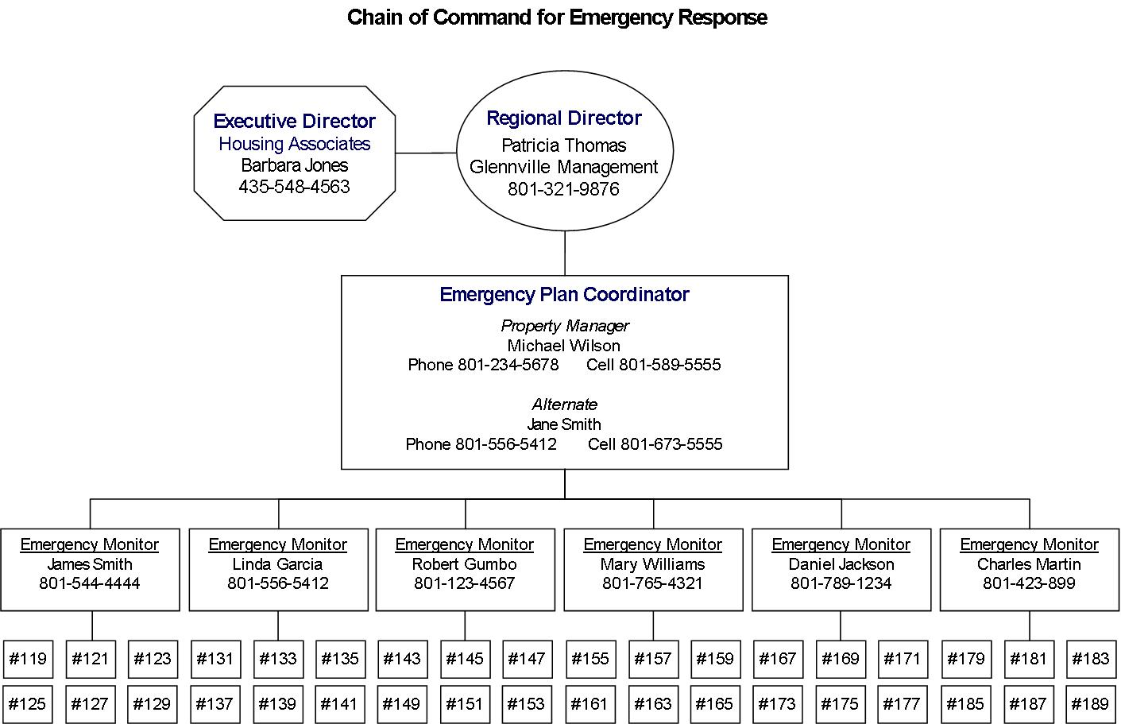

- If any member of the Chain of Command is unavailable, bypass their position and contact their superior or subordinates directly using contact information provided in the Communication section.
- Communicate the situation and status of residents to the Regional Director and Executive Director as soon as possible.
- Continual collaboration between building management (Regional Director and Property Manager) and local and community leaders (City, County, Association of Governments, etc) will help ensure seamless responses to emergency situations. Therefore, building management is urged to take part in local emergency planning, discussions, activities, and exercises.

Shelter-in-place Procedures

Sometimes disaster response requires that tenants not evacuate, but rather stay in their apartments; this is known as "sheltering-in-place." The fire or police department warnings to "shelter-in-place" could include:

"All-Call" telephoning—an automated system for sending recorded messages, sometimes called "reverse 9-1-1."

Emergency Alert System (EAS) broadcasts on a television or battery-operated radio.

Outdoor warning sirens or horns.

News media sources— battery-operated radio, television, cell-phone, or internet.

NOAA Weather Radio alerts.

Residential route alerting—messages announced to neighborhoods from vehicles equipped with public address systems.

In the event a shelter-in-place is necessary, follow any instructions given by property managers and emergency officials, although common procedures include:
- Bring all household members, including pets, indoors immediately.
- Close and lock all outside doors and windows.
- If you are told there is danger of explosion, close the window shades, blinds or curtains.
- Turn off the heating, ventilation or air conditioning system. Turn off all fans, including bathroom fans operated by a light switch.
- Get your disaster supplies kit and make sure the battery-operated radio is working.
- Take everyone, including pets, into an interior room with no or few windows and shut the door.
- If you have pets, prepare a place for them to relieve themselves where you are taking shelter. Pets should not go outside during an emergency because outdoor conditions may be harmful to them and they may track contaminants into your shelter. The Humane Society suggests that you have plenty of supplies to help deal with pet waste.
- If you are instructed to seal the room, use duct tape and plastic sheeting, such as heavy-duty plastic garbage bags, to seal all cracks around the exterior doors. Tape plastic over any windows and over any vents. Seal electrical outlets and other openings. Reduce the flow of air into the room as much as possible.
- Call your emergency contact and keep the phone handy in case you need to report a life-threatening condition. Otherwise, stay off the phone so that the lines will be available for use by emergency responders.
- Keep listening to your radio or television until you are told all is safe or you are told to evacuate. Do not evacuate unless instructed to do so.
- When you are told that the emergency is over, open windows and doors turn on ventilation systems and go outside until the building's air has been exchanged with the now clean outdoor air.

Evacuation Plan

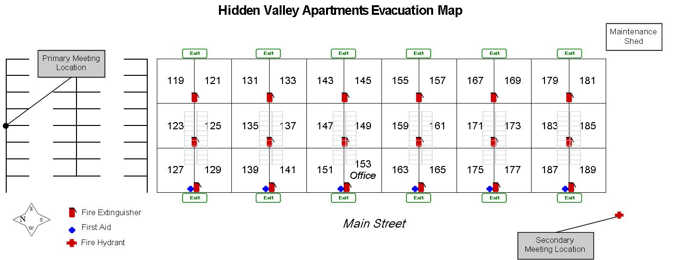
Do Not Use Elevators during evacuation procedures.
The primary meeting location will be the parking lot North of the building. In case this location is inaccessible, please meet near the fire hydrant West of the building.

Emergency Shelters:

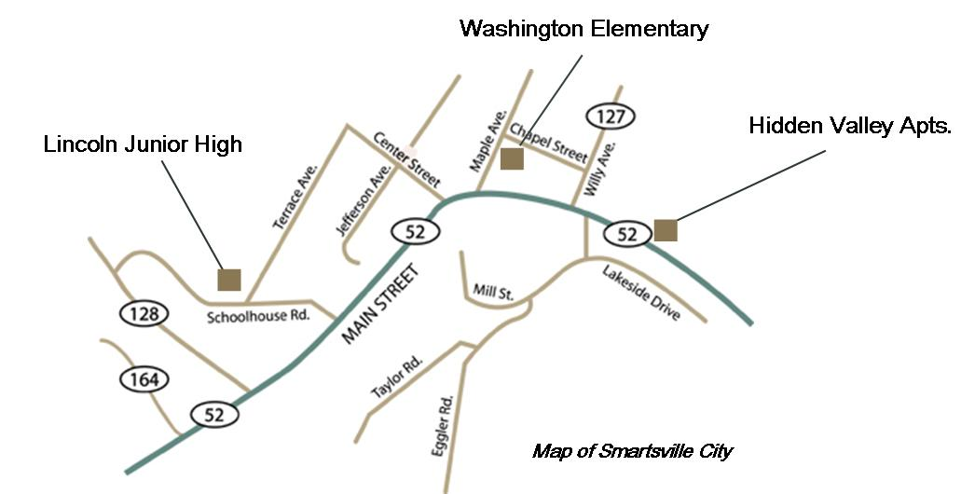

Washington Elementary
123 Maple Ave
Smartsville, UT
(801)555-5555
Lincoln Junior High
350 North Schoolhouse Rd.
Smartsville, UT
(801) 123-4567

Supplies & Resources

The building does not have adequate space or resources to stockpile food or water for residents. Therefore, the responsibility for food and supply storage lies mostly upon the residents. During orientation, residents are given an information packet which includes:
- Be Ready Utah Guide to Personal and Family Preparedness
- List of recommended supplies for a 72-hour kit
- Suggestions on how to develop a Family Emergency Plan
- List of training resources available in the community (CERT, CPR, First-Aid)

The following supply source agreements have been made:
Supply | Source | Contact | Location
Plywood | Home Center* | Jim Smith | 328 West 2100 South, SLC
Generators | United Rentals * | Tim Taylor | 955 West 2100 South, SLC
Tarpaulin | Lowe’s* | Stephanie Smith | 358 East Canyon Rd, SLC
Disaster Cleanup | Pride Cleaning & Restoration | Monte Carmichael | 5645 S State, Sandy, UT
*Communications with these vendors as to their disaster planning status does not present a contractual or bid problem. A minimum inventory of some critical items have been identified and stocked in the stores warehouses above normal sales justification.

The following is a list of VOAD’s in the area:
Volunteer Organizations Active in Disaster | Contact | Phone
American Red Cross of Utah | Brett Cross | 801-323-7000
LDS Church Emergency Response | Melvin Gardner | 801-240-1499
Lutheran Emergency Response Team (LCMS) | Bob Schrank | 801-268-4277
Southern Baptist Disaster Relief | Wade Gayler | 801-703-8734
State of Utah, Commission on Volunteers | Jeff Johnson | 801-538-3644
United Methodist Church | Sam Loftin | 801-231-4425
Utah 2-1-1 | Lorna Koci | 801-870-7148
Utah Department of Health | Mike Stever | 801-440-9563
Utah Homeland Security | Rey Thompson | 801-330-4343
Local CERT Contact | Mike Weibel | 435-994-1122
Local Neighborhood Watch Team Leader | Megan Moore | 801-561-5468

The following is a list of residents with specialized training which may be useful in an emergency:
Training | Resident | Apartment | Phone
Retired Doctor | Phil McGraw | 155 | 801-591-7516
Retired Nurse | Clara Barton | 179 | 801-445-5667
Retired Nurse | Margaret Houlihan | 127 | 801-234-5678
Retired Nurse | Beverly Crusher | 173 | 801-543-2109
Ham Radio | Geordi La Forge | 159 | 801-761-5461
Cert Trained | Dwight Schrute | 123 | 801-315-7591
Cert Trained | Mike Smithson | 135 | 801-513-8318
Cert Trained | Jennifer Jansson | 141 | 801-453-8432

Inspections
In the event of a vacancy, emergency checklist items involving entrance into each unit will occur along with typical move-out procedures. Otherwise, analysis will be performed by the property manager annually. At least 24 hours notice must be given to visually inspect each unit.

Drills and Practice
Emergency and evacuation drills will occur on a semi-annual basis and are initiated by the Emergency Coordinator. At the end of the procedure, the Emergency Coordinator will meet with the Emergency Monitors to discuss the outcome of the drill including evacuation time, unforeseen problems, and recommendations to streamline and make the plan more effective. The Coordinator will then make the appropriate changes to the plan, and communicate them to the Monitors and residents.

Appendix

Current List of Residents

Sample Emergency Response Agreement

Annual Emergency Review Checklist

Structural Assessment Checklist

Evacuation Map

Current List of Residents
Name | Apt. | Phone | Special Requirements
Michael Adams | 119 | 435-781-7164 | Mobility impaired, may need wheelchair assistance
James Smith* | 121 | 801-544-4444
Dwight Schrute | 123 | 801-315-7591
Kathryn Burke | 125 | 435-458-2124
Margaret Houlihan | 127 | 801-234-5678
Daniella Holden | 129 | 801-786-8436 | Mobility impaired, may need assistance
Linda Garcia* | 131 | 801-556-5412
Keith Hardy | 133 | 435-584-4546
Mike Smithson | 135 | 801-513-8318
Adam Ward | 137 | 435-816-5464 | Only speaks Spanish
Laura & Kevin Smith | 139 | 801-546-6545
Jennifer Jansson | 141 | 801-453-8432
Robert Gumbo* | 143 | 801-123-4567
Manuel Hendriksson | 145 | 435-642-1564
John Martinez | 147 | 801-742-5445
Greg Kilson | 149 | 801-987-5357 | Mobility impaired, may need assistance
Kendra & Sam Johnson | 151 | 801-531-5438
Office | 153 | 801-234-5678
Phil McGraw | 155 | 801-591-7516
Michele Salazar | 157 | 435-453-4561 | Only speaks Spanish
Geordi La Forge | 159 | 801-761-5461 | Visually impaired
Larry Stenson | 161 | 801-921-4355
Sydney Silverstein | 163 | 435-821-5314
Mary Williams* | 165 | 801-765-4321
Astrid Lundgren | 167 | 801-584-6433 | deaf or hard of hearing
Daniel Jackson* | 169 | 801-789-1234
Steve & Janice Young | 171 | 801-624-5614 | Only speak Spanish
Beverly Crusher | 173 | 801-543-2109
Sean McVeay | 175 | 435-897-1358 | Mobility impaired, may need wheelchair assistance
Van Nyuen | 177 | 801-453-5689
Clara Barton | 179 | 801-445-5667
Peyton Warner | 181 | 435-531-5461
Charles Martin* | 183 | 801-423-8989
Derek Walker | 185 | 801-561-8469 | Only speaks Spanish
Jane Smith | 187 | 801-556-5412
Chris & Lisa Meyer | 189 | 435-738-8164
* Emergency Monitor


Shine Cleaning & Restoration
5645 South State St., Sandy, UT 84256
(801) 894-6544
info@shinecleaning.com

Emergency Response Agreement (ERA)

This Emergency Response Agreement (ERA) is made by and between Glennville Management, Inc., “The Company”, with facilities located at 153 Main St, Smartsville, UT 84123 (any additional facilities should be listed on the Emergency Response Information Sheet), and Shine Cleaning and Restoration, Inc., the “Contractor”, of 5645 S State, Sandy, UT 84256, in accordance with the following agreed upon terms and conditions:

Terms and Conditions:
1. In the event of a disaster related call from the Company, Shine Cleaning and Restoration will call back within 15 minutes and be on-site within two (2) hours barring natural extenuating conditions or traffic congestion (provided the Company facility is within a 60 mile radius). The emergency call may result from a storm, fire, flood, or other natural or man-made, non-hazardous disaster.
2. Shine Cleaning and Restoration will clean up, contain and/or mitigate the loss caused by the emergency reported, by supplying tools, equipment, materials, labor and other necessary items and sub trades as needed.
3. Shine Cleaning and Restoration will supply certified personnel trained in accordance with Occupational Safety and Health Administration (OSHA) standards.
4. Shine Cleaning and Restoration has and will maintain commercial general liability, environmental liability, and workman’s compensation insurance.
5. Shine Cleaning and Restoration and its employees will keep all information pertaining to the emergency situation confidential, unless otherwise required by law, or to protect life, safety, or health.
6. If unsafe conditions occur while Shine Cleaning and Restoration is performing services, or if directed by Federal, State or Local Officials, either Shine Cleaning and Restoration or the Emergency Coordinator will have the right to stop work on the project.
7. The attached Emergency Response Information Sheet is incorporated into this Agreement.

The above mentioned parties in mutual agreement hereto have executed this Agreement this 18th day of November, 2009 and is in effect for one (1) year.

Glennville Management
Signed:
Printed Name: | Barbara Jones
Title: | Executive Director
Shine Cleaning and Restoration, Inc.
Signed:
Printed Name: | Collin Smith
Title: | Owner, CEO

Structural Assessment
Based on the latest structural assessment performed June 25, 2007 by Smoot and Associates Engineering the following findings are recommended for repair:

 | Repaired |  | Date
1. Small cracks along Northwest foundation. Because of the recently reinforced concrete, these most likely appeared following the completion of the renovation. |  |  | 7/2008
2. Water heaters not fastened to wall stud or floor. |  |  | 8/2007
3. Exposed wire insulation in attic between stairwell 2-3 (possible infestation) - fire and power outage hazard.
4. Extremely dry field grass in open field south of the maintenance structure, presenting a fire hazard. |  |  | 8/2007
5. Rain gutters along front of building have not been appropriately cleaned out, which could lead to water leaking under shingles, and other water damage. |  |  | 10/2007
6. Rain gutters along rear side of building are not sufficiently attached, and are becoming separated from the building. |  |  | 10/2007
7. Attic not sufficiently vented, trapping extremely hot air in the summer. This could potentially be a fire hazard, and decrease effectiveness of building materials. Install gable end and roof vents.

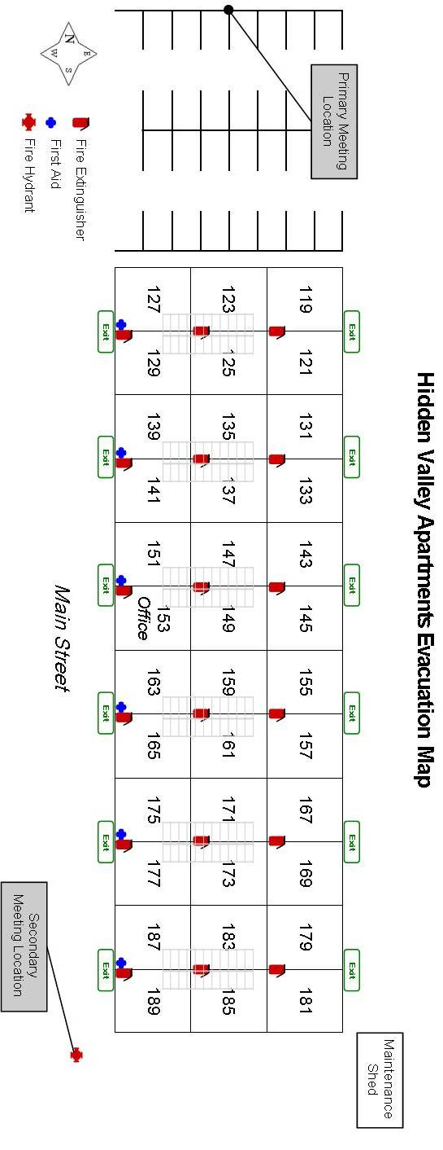

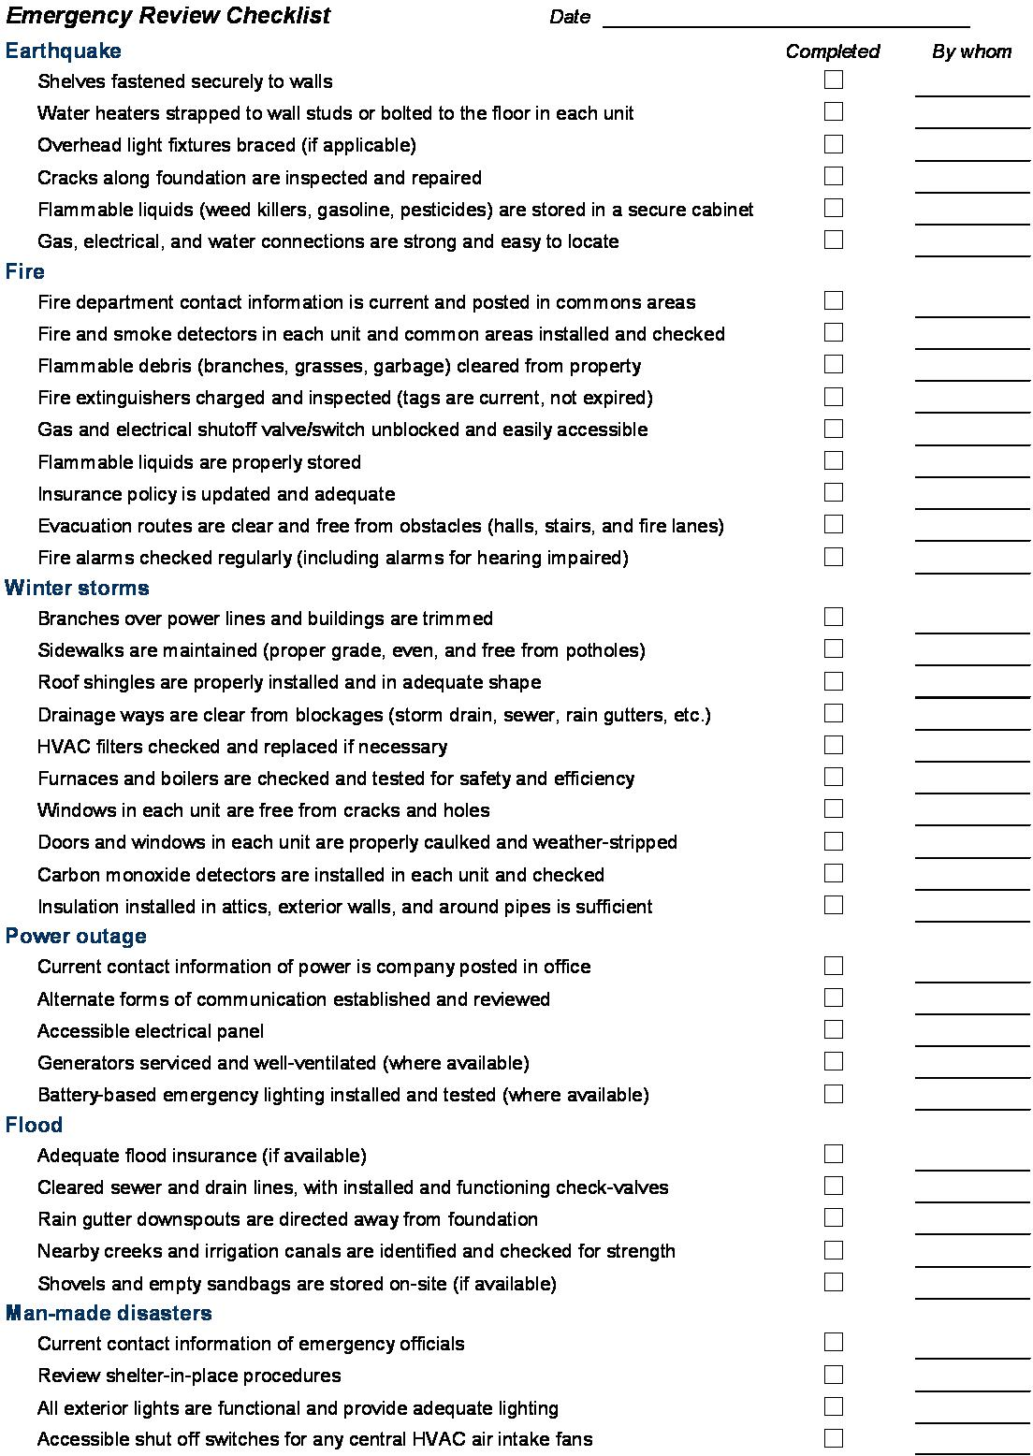
Most Recent Inspection Checklist

